Face Recognition Access Control System

1. Installation
   1. Ubuntu 16.04
   2. run install.sh
      1. opencv 3.2.0   
         follow the install.sh
      2. pyqt4  
         stop updating
      3. PyMySQL 0.7.11
      4. libboost-all-dev 1.58.0
      5. dlib 19.7.0
      6. scipy 0.19.1
      7. numpy 1.13.3
      8. Pillow 4.3.0
      9. Click 6.7
      10. face_recognition 1.2.1
      11. python-serial 3.0.1
2. Set Up
   1. Machines
      1. put tk_ver.py in home folder
      2. System Settings -> User Accounts -> Automatic Login ‘On’
      3. nano ~/.xprofile

#!/bin/bash

xset -dpms

xset s off

sleep 30

echo '123456' | sudo -S python /home/access/tk_ver.py

this is the shell auto run the program

and prevent screen goes blank

sleep 30 seconds for internet connection start

* + 1. sudo crontab -e

put “0 4 * * * /sbin/shutdown -r” at the end

auto reboot at 4:00 am everyday

* 1. Manage System
     1. Run back_end.py
     2. or creat a shell file
     3. shell sample is in the folder

1. Usage
   1. Machines
      1. Touch the RFID Card to the reader
      2. Make sure your face stay in the screen and the red square recognize it
   2. Manage System
      1. System screen shot

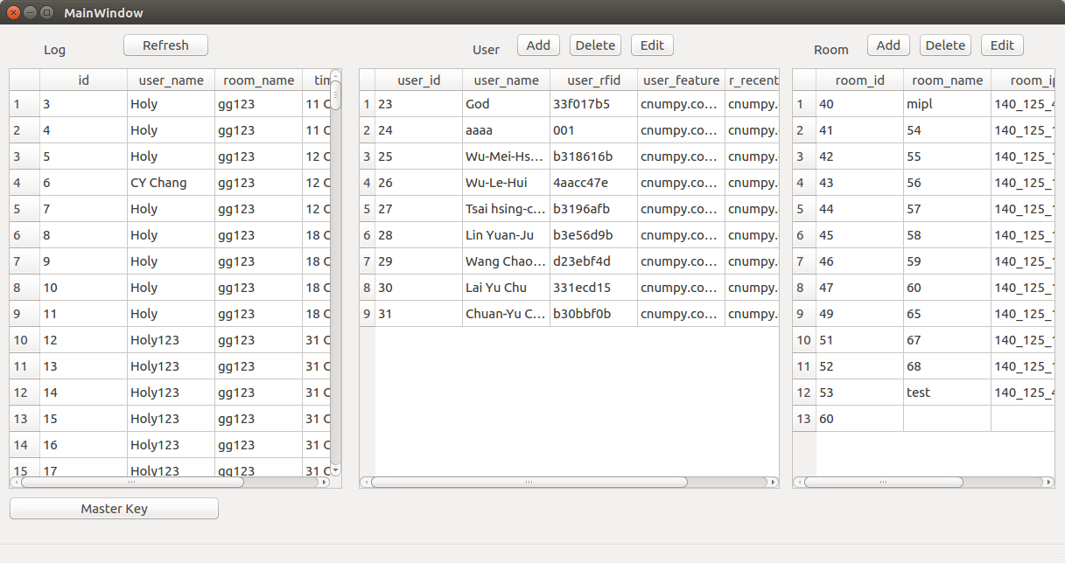

Left: Entry Logs

Mid: Users

Right: Rooms

Down Left: Change Master RFID Card Number

* + 1. Add User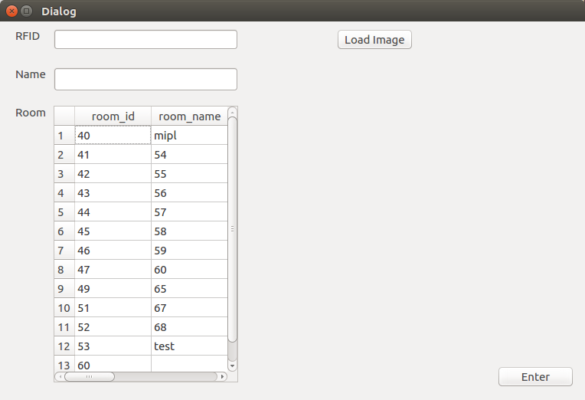

Enter RFID card number using card reader

Enter Name

Highlight the access permissions to each rooms

Press Load Image to chose a image with clear face

Press Enter

* + 1. Delet User

Hightlight “A” user

Press Delete

* + 1. Delet Room

Hightlight “A” room

Press Delete

* + 1. Add Room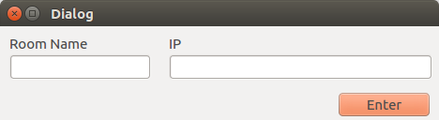

Enter Room Name

Enter IP

Press Enter

* + 1. Edit Room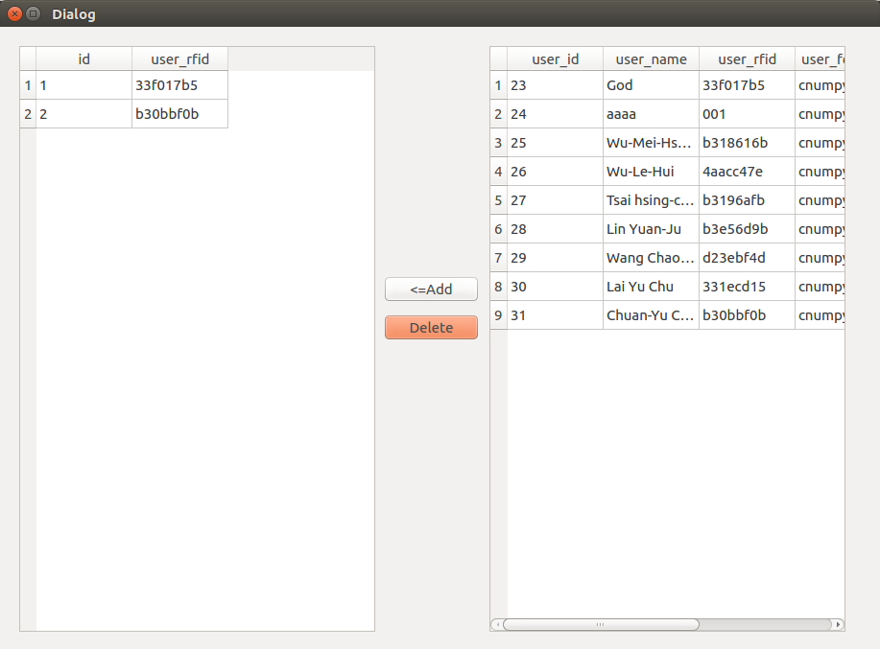

Left: Users who can enter this room

Right: All users

Highlight a user from the right

Press <=Add to grant permission to access the room

Highlight a user from the left

Press Delete to cancel the permission

* + 1. Master Key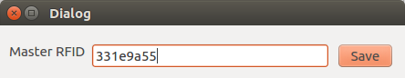

Touch the master rfid card to the reader

Press Save